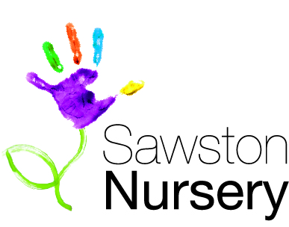**~ 01**

**COVID19 Operation Plan**

**For Sawston Nursery Parents and Children**

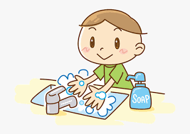

**First Published 22/05/2020,**

**Updated 12th June 2020, Updated 19th June 2020 Updated 3rd July 2020 Updated 21st July 2020**

**Introduction**

Our primary aim in reopening is to do so in the safest possible way for children, staff and parents/carers. To be able to achieve this, we have put into place a number of procedures and will ensure these are followed strictly.

We accept the day to day working of the nursery will not be exactly the same as before, however this is the way we believe it is safer to reopen.

Children should not feel a significant difference in their nursery experience despite having reduced access to some resources. Staff are familiar so the children should feel comfortable and well cared for at nursery.

At Sawston Nursery we are aware that COVID19 continues to cause concerns and worries for parents/carers whose children would usually attend the nursery.

We have decided to write an Operation Plan and share this with you where we hope you will feel reassured that we will do everything possible to minimise any risks of transmission of the virus.

We have used guidance from the Department of Education and Government information for the reopening of childcare settings to create protective measures for all children, their families and the staff working in the nursery.

Following the Department of Education and Government Guidelines (2 July 2020) we feel confident that we are able to offer protection to the best of our capability within our learning environment.

Sawston Nursery will inform the Local Authority and Public Health England Health Protection team of any confirmed case of COVID19 in staff or children.

**So, what’s included in our Operation Plan?**

* Transition back into Sawston Nursery
* Safer access guidance
* Health and Safety/Risk Assessments
* Personal Hygiene Practices
* Well-Being
* Travel/Visitors to Sawston Nursery
* 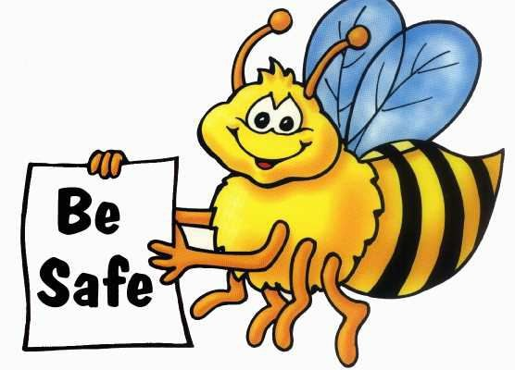Food Preparation and Kitchen Hygiene

**Transition back to Nursery**

* Parents will be requested to complete an, ‘All about my time at home sheet’ before returning to the nursery. This will enable us to find out what your child has been doing and for us to support their learning (Please e mail to [office@sawstonnursery.org](mailto:office@sawstonnursery.org)).
* Parents to ensure safety measures are discussed with their child prior to their return.

For example, sharing our handwashing link where Karen S will show your child how to wash their hands thoroughly at home and at nursery (Please see section under Personal Hygiene Practices).

* Create a ‘countdown’ to starting Nursery, show your child the calendar in advance noting when they will be returning (Depending on their age).
* Read stories at home with your child about transitions and returning to the nursery.
* Please explain to your child the new situations in nursery and the meaning of a ‘Bubble Group’

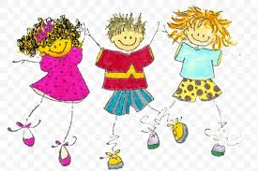(This is explained within the plan, page 6).

**Safe Guidance Access to Sawston Nursery**

* We will expect families to be symptom free of illness when they drop off and collect their child from nursery.
* A familiar adult should drop off your child and collect to prevent different people entering the porch of the nursery.
* When you drop your child off at the nursery there will be tape on the paving slabs and signage where we ask that you stand 2 Metres apart from other families and remember to social distance.
* To prevent parents/carers entering the nursery you will be required to drop off and collect your child from the porch entrance of the nursery.
* Hand sanitiser will be available for you to sanitise your child’s hands before they enter the nursery.
* Parents/carers are to sanitise their own hands before using the pen/pencil provided to sign their child into the nursery or press the buzzer to communicate with nursery staff.
* Staff entering the nursery will enter from the left of the porch and we ask that parents/carers give priority so that staff are able to prepare themselves and be in the classroom to greet your child.
* All emergency exits must remain clear at all times. If the fire alarm is activated staff and children must still keep 2 meters distancing when at the evacuation point and stay in their classroom groups.
* 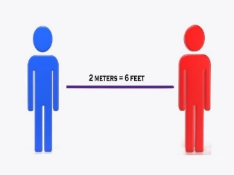Please provide a change of clothes for your child in a bag which can be left at nursery. Bags will then remain onsite unless items of clothing need washing and replacing.
* We can always add clothing to the bags if you wish to bring items into nursery.

**Classrooms across the Nursery**

The Government Guidance (Dated 20th July 2020) informs ***‘early years settings will no longer be required to keep children in small, consistent groups within settings.*** Settings should still consider how they can minimise mixing within the settings, for example where they use different rooms for different age groups, keeping those groups apart as much as possible.

* we will be operating within the 5 classrooms across the nursery from 20th July 2020 where children who have been in small bubble groups will re-join their peer groups within their original classroom.
* the government recognises the physical layout of a setting does not allow groups of children to be kept 2 meters apart throughout the day. However, staff will exercise their judgement in ensuring the highest standards of safer operation is maintained at all time.
* familiar adults will be placed in the classrooms and be responsible for the children’s care during the day.
* The adults will remain with the children to prevent any mixing of groups and adults in the nursery

‘wherever possible’.

* We will use the outdoor area as much as possible which will also be divided to ensure safer play takes place.
* We will use our space carefully depending on the numbers of children returning to the nursery as safety remains paramount to everyone.
* Outdoor spaces to be used for snack time weather permitting.
* Staff will minimise contact and mixing of children across the nursery where children are not in their classroom group.
* Use of the toilet and communal internal areas will be restricted and monitored at all times.
* Within our baby room the cots will be positioned 2 meters apart and bed lining for all children in the nursery will be changed after every use per child.

**Health and Safety Risk Assessments**

* We have a clear, robust risk assessment in place (which can be shared upon request from parents/carers) so we are able to offer safer operating in the workplace.
* Staff will have guidance of appropriate PPE and the operating procedures we have in place at the nursery.
* We will minimise contact and mixing of children in different classrooms and stagger lunch breaks for staff.
* If a child has been given Calpol (or similar medication) prior to coming to nursery they will not be permitted to attend. If we subsequently find out a child has been given Calpol prior to coming to nursery a parent will be asked to pick up their child.
* If a child displays symptoms and have a temperature of 38, they will be removed from the classroom by a member of staff immediately and taken to an isolated area, (Managers office) until the child is collected by their parent.
* If a child is to display symptoms, appropriate PPE is available such as a mask, gloves, and apron which will be worn by the member of staff accompanying the child.
* Early Years and Childcare settings should direct staff/children who have symptoms to book a test online – [www.NHS/coronavirus or by dialling 119](http://www.NHS/coronavirus%20or%20by%20dialling%20119).
* If you have recently visited a country where a 14 day quarantine period is necessary please see the list of countries that are exempt from the quarantine requirement at : <https://www.gov.uk/coronavirus-covid-19-countries-and-territories-exempt-from-advice-against-all-but-essential-international-travel> (Last updated 27th July 2020).
* Resources that cannot be washed will be temporarily removed from the classroom to prevent the risk of germs being transmitted.
* Staff will ensure they avoid any person with symptoms.
* The staff room area will accommodate four adults at one time (which is maximum capacity to ensure safer social distancing).
* If parents, children, and staff are able to walk or cycle to nursery the government guidance advised this where possible.

**Personal Hygiene**

* Staff and children will be expected to wash their hands more frequently and wash for 20 seconds with running water and soap and dry them thoroughly.
* Firstly, on arrival at the nursery and then wash their hands throughout the day, particularly after using the toilet, and before and after eating any food.
* All staff and children must sanitise their hands thoroughly and regularly.
* Hand sanitiser will be provided in all classrooms and areas around the nursery.
* Children and adults to be discouraged from touching your mouth, eyes, and nose.
* All nappies and waste will continue to be disposed of in a hygienic manner.
* All gloves and PPE will be disposed of immediately after use, in a closed bin.
* Please discourage your child from bringing any resources or toys in from the home unless this is essential, and this will mean the item must be sanitised on arrival by a member of staff before entering the nursery.
* Posters will be displayed in the nursery to show good hygiene practices.
* Remember good respiratory hygiene by promoting the ‘catch it, bin it, kill it,’ approach.
* Use your elbow or a tissue to cough or sneeze and use bins for tissue waste.
* Clean areas frequently which are touched using standard products provided in the nursery.
* Children will be encouraged to learn and practise these habits through games, discussions, songs, and repetition with adults in the nursery and home environment.
* Our cleaning company will enter the building at the close of nursery to ensure all areas are cleaned to a very high standard.
* No flannels or towels will be shared by any child. Following our usual hygiene routines and these will be washed after each use.
* Staff will ensure that where possible, all spaces should be well ventilated using natural ventilation (open the windows).
* Staff will prop doors open where safe to do so to avoid use of door handles and aid ventilation.
* Room leaders will be responsible for organising the regular sanitising of door handles, doors, windows, light switches, toys, play equipment and hard surfaces throughout the day.
* Lockers must be used for all staff to store their personal belongings.
* Staff to provide their own mug and are responsible for washing this. No washing up is to be left in the sink area and must be cleaned after use.
* Staff lunches to be in a sealed bag or container and stored in the relevant fridges or their locker. No paper or plastic carrier bags.
* Toilet areas will be cleaned thoroughly every hour. Room Leaders to organise this and record on a check sheet.
* Staff hair will be tied back to avoid contact with the face.
* Staff should not wear any jewellery such as rings (although wedding rings are acceptable) and bracelets. Earrings may be worn but must be studs.
* If staff are using public transport to travel to work, they must wear their own clothing and change on arrival at the nursery to reduce the chances of transmitting the virus through clothing.
* The management team will carry out regular spot checks to ensure cleaning is of a high standard throughout the nursery.

**Karen, our Outdoor Learning Coordinator** has a ‘You Tube Video Clip’ demonstrating good hand washing practices. Please share this with your children before their return to nursery and encourage them to do the same.

<https://www.youtube.com/watch?v=CJgNHDcAXLU&feature=share>

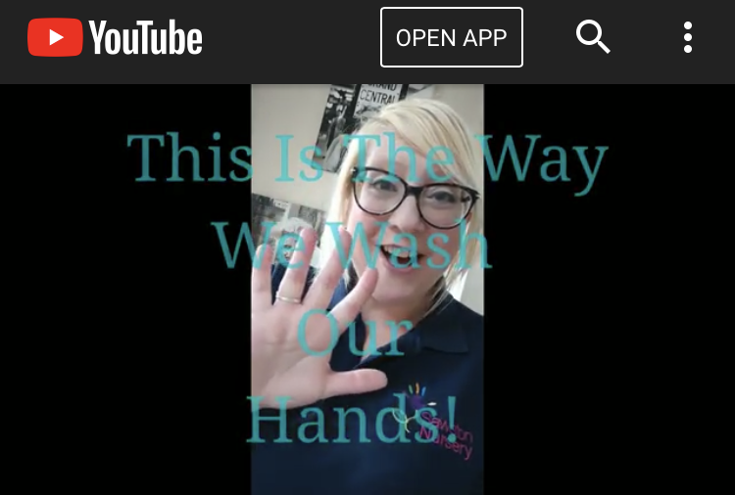

**Well Being**

* Staff will support children returning to the nursery and help them to gain a good understanding of why we must have safer operations and practice good hygiene routines at all times.
* Through imaginative play staff will teach the children about social distancing and the importance of changes we are now having to take on board in our lives.
* We will support children during the settling in period at nursery and use the ‘All about my time at home form’ to understand and familiarise ourselves with their individual needs. Furthermore, we will encourage the forming of good attachments with staff and children in your child’s classroom group.
* Staff will plan for children’s social and emotional reintegration into the nursery, considering the child’s specific needs.
* Activities will support and nurture children in developing their social and emotional well-being and resilience.
* Paperwork may be reduced initially whilst children, staff and management adjust to the new normal. However, this does not mean that you will not be given verbal feedback daily.
* Handover at the end of your child’s day will be 5 minutes maximum as we will only be able to talk to one parent at a time. Parents/carers will receive a handover sheet if your child is in the Buttercup or Bluebell Room.
* 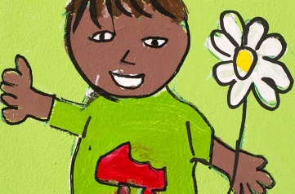Feel free to e mail or use Tapestry to contact and share information with us and we will get back to you as soon as we can.

**Travel/Visitors to Sawston Nursery**

* When you arrive at the nursery please do not park your car outside the main doors. You will be expected to use the car park provided.
* Any bikes, buggies, scooters, and car seats can not be left at the nursery at this current time.

You will need to take these home with you.

* Bikes can be locked and parked in the cycle area close to the car park. These will be left at your own risk. The nursery cannot be held responsible for damage or theft.
* Outings will not be taking place at this current time from the nursery such as the pre-school annual trip. However, children can be taken off site with parental permission for walks in push chairs, and nature walks in the neighbouring orchard (20th July 2020)
* Sawston Nursery will not allow any visitors in the building apart from emergency maintenance where needed and our cleaning company (After close of the nursery).
* Any deliveries to the nursery will be dropped off outside the entrance area of the nursery.

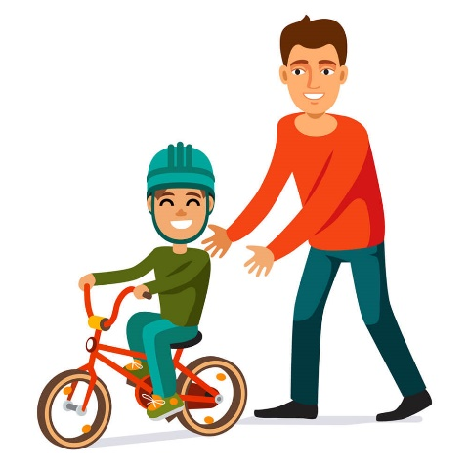

**Food Preparation and Kitchen Hygiene**

* Our cook will provide all snacks, lunches, and tea to children in the nursery.
* Our cook will deliver the meals to each room for the children and leave outside the classroom door for collection by a member of staff.
* When mealtime is over our cook will collect the trolley from outside of the classroom door.
* Our cook will wear appropriate PPE to minimise the risk of contamination to the food.
* Disposable gloves must be worn by all staff throughout serving any food to the children.
* Our cook will be solely responsible for the food deliveries where disposable gloves must be worn on collection of the food from either the back gate of the nursery or the front entrance. A member of the kitchen staff team or management team will assist our cook in transferring the food deliveries to the external kitchen door.
* After delivery, our cook will ensure all items of food are washed prior to storage.

