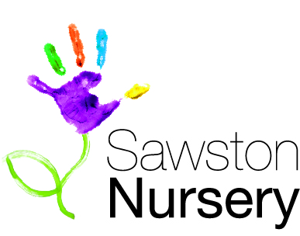
Sawston Nursery

Babysitting

Sawston Nursery does not provide a babysitting service outside of operational hours. However, we do understand that parents/carers sometimes ask the nursery staff to babysit for their children.

This policy has been implemented to ensure clear understanding and clarification of some points regarding private arrangements between staff and the parent/carer.

- Sawston Nursery is not responsible for any private arrangements or agreements that are made. Out of hours arrangements must not interfere with a staff member’s employment at the nursery.

- The individual must always uphold the Data Protection Act 1998 therefore discussions about the setting, other children or parents and employees of the setting is not permitted and would be considered breach of contract.

- Parent/carer should be aware that any other adults accompanying the staff babysitter may not have a relevant DBS clearance and it may not be appropriate for them to care for children.

- Sawston Nursery will not be held responsible for any health and safety or any other issues that may arise from these private arrangements.

- We do not have control over the conduct of staff outside of their position of employment and our duty to safeguard children as above therefore does not extend to private arrangements.

- The individual who is babysitting must declare any income received from babysitting as this could be taxable income, which should be declared to HMRC.

- The rights of the parent to see the DBS certificate of the individual caring for their child/ren.

This Policy was adopted by | Sawston Nursery
On | December 2016
Updated on | September 2019
Signed on behalf of the setting

